Knowledge, Attitudes and Perceptions of COVID-19 Vaccination among Healthcare Workers Public Hospitals in Bungoma County,Kenya.  Author: Vincent T.Aliong’o  Organization: Webuye county Hospital.  Country: Kenya  Email: aliongov@gmail.com  Co-author: Nimrod Omuli  Organization: Bungoma West Hospital. |  | 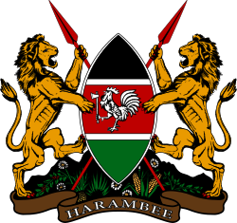
Introduction  - Bungoma County is one of the countys most affected by the COVID-19 pandemic in the Kenya.  - Healthcare workers are among those at high risk of contracting the virus, and a vital source of  information and trust in vaccines to the  community.  Method  This study was conducted about attitudes towards  COVID-19 vaccination among healthcare workers at a  public hospital in Bungoma County during the  beginning of COVID-19 vaccination.400 hospital  employees responded.  Results  - Several factors were significantly associated with vaccine attitudes, including demographics  such as gender (p = 0.002), age (p = 0.005),  race (p&lt; 0.001) and home location (p &lt;  0.001),role within the hospital (p &lt; 0.001),  knowledge about the virus (p &lt; 0.001) and  confidence in and expectations about  personal protective equipment and behaviors  (p &lt;0.001).  - Structural equation modeling revealed that the most predictive factors were prior vaccine attitudes and concern with the speed of testing and approval of the vaccines (p &lt; 0.001).  - Multivariate analysis reinforced these, while also identifying perceived personal risk as significant (p = 0.033).  Conclusion  Several modifiable factors that reflect confidence in science, scientific knowledge, personal risk perception, experience and medical authority are correlated with vaccine attitudes, indicating that a holistic educational approach to improve trust in science is likely to be effective in long-term reduction in vaccine hesitancy. | Table 1: Socio-demographic characteristics among  healthcare workers in Bungoma County.  Question Frequency(n) Percentage(%)  Sex: Female 194 48.5  Male 208 52  Age (yrs)20-30 177 44.3  31-40 174 43.5  41-50 27 6.8  51-60 20 5.0  Profession  Medical doctor 24 6  Laboratory technician 36 9  KRN 230 57.5  Pharmacist 20 5  Radiographer 10 2.5  Anesthesiologist 2 2.0  Public health officer 26 6.5  Nonmedical auxiliary staff 40 10  Figure 1: Survey responses were unevenly distributed among hospital employees, with an abundance of Nurses .However multiple roles in all aspects of hospital employment are represented.  Figure 2: Source of information  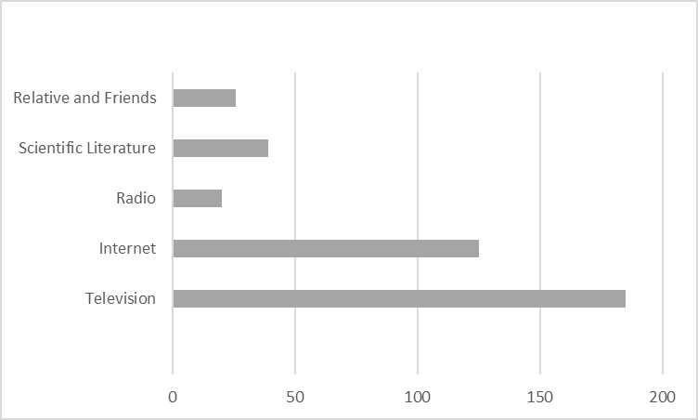
- BBC. Covid-19 Africa : what is happening with vaccines ? Which countries are using up [Internet]. 2021. Available from: https://www.bbc.com/news/56100076.
- Paul E, Steptoe A, Fancourt D. Attitudes towards vaccines and intention to vaccinate against COVID-19: Implications for public health communications. Lancet Reg Health - Eur. 2021;1:100012. .
- WHO. Ethiopia introduces COVID-19 vaccine in a national launching ceremony [Internet]. 2021. Available from: https://www.afro.who. Int/news/ethiopia-introduces-covid-19-vaccine-national-launchingceremony.
- African Vaccine Acquisition Trust delivers 108,000 doses of COVID19 vaccine to Ethiopia – Africa CDC [Internet].
2021. Available from: https://africacdc.org/news-item/african-vaccine-acquisition-trust-deliv ers-108,000-doses-of-
covid-19-vaccine-to-ethiopia

